ECON 1035 – BUSINESS STATISTICS 1: PROJECT
Instructions:

This is a group assignment with a minimum group size of two and a maximum group size of three. All group members must be enrolled in the same local lecturer tutorial group. There will be two parts to this assignment:

Part A: Report to the Business Dean Part B: PowerPoint slide presentation suitable for an audience representing the incoming student cohort to Business Statistics.
This assignment, along with a Micro-credential component, is worth 40 marks. The allocation of marks is as follows:
Part A | 30
Statistical Analysis (including excel) | 22
Professional Report | 8
Part B | 8
Sub-total | 38
Micro-credential* | 2
Total | 40

*This is a separate submission and the grade will appear separately on Canvas for each student.

The response to Part A must be provided in the form of a professional report with no more than 8 pages (including cover page). The structure of your professional report must include
1] A Title, 2] An Executive Summary, 3] An Introduction, 4] Analysis (Part A) and 5] Conclusions.

The response to Part B must be provided in the form of a PowerPoint slide presentation with no more than three slides.

In addition, you need to complete a Micro-credential on cross-cultural communication. To show evidence of successful completion you need to provide a copy of the badge. You have the option of completing the Micro-credential earlier in the semester and making a separate submission on Canvas. Alternatively, you can provide the badge along with your assignment submission. You have ONLY 2 attempts and you need a score of 80% to receive a badge.

You must submit an electronic copy of your assignment in Canvas. See the attached Template of your submission for more details. Only one submission is required per group. Hard copies will not be accepted. It is very important that you submit an assignment cover sheet with all the group members’ signatures at the time of submission. If any dispute arises on your contribution to the group work, the cover sheet will be used as evidence of contribution.

This assignment requires the use of Microsoft Excel. If you have Windows, you will need to use the Data Analysis Tool Pack. If you have a Mac with Excel 2011, you may need to use StatPlus:MAC LE. You will need to include your Excel output as an excel file submitted with your report. The excel file needs to be clear and carefully organised and must show all workings underlying the Professional report and associated statistical analysis. It will be treated as an appendix to your report, i.e. not included in the page count. Do not refer to the excel workbook within the Professional report. You will need to take the results from your workbook and incorporate into your report. As an example for the regression results in question 5 you will need to present the results in traditional form e.g.

Final_exam = 2.05 + 1.8Tutorial_ attend
(1.7) (0.45)
Figures in parentheses represent standard errors
No. of observations 737, Rsquared 0.29. (These results are illustrative only- i.e. I made them up.)
Then you would interpret and carry out relevant hypothesis tests.
Presentation Instructions:
Your written professional report should comply with the following presentation standards:
1. Typed using a standard professional font type (e.g. Times Roman), 12-point font size.
2. Single or 1.5 line spacing, numbered pages, and clear use of titles and section headings.
3. Delivered as a Word (.doc or .docx) or PDF (.pdf) file
4. Checked for spelling, typographical and grammatical errors. Where relevant, round to 3 decimal places.
5. With all relevant tables and charts, the report should be no more than 8 pages long.

Problem Description:
You have been appointed by the Dean of Business to analyse student performance in a course offered by the Business School. The data provided are real but not from RMIT. The focus is upon the key determinants of the Final_exam (i.e. the students’ final exam mark), in particular the role of the Assignment (i.e. Assignment_grade) and Tutorial_attend (i.e. the number of tutorials attended during the semester). Using the tools learned in your current Business Statistics course provide the Dean with an analysis of Final_exam performance. You may assume the Dean has a good understanding of basic statistics. In addition the Dean would like you to prepare a PowerPoint presentation to illustrate the key findings of your analysis to the incoming student cohort. Unlike the Dean, the cohort has not yet studied business statistics.
There are two parts to this assignment, each of which is described in detail:
Part A (3 + 2 + 3 + 2 + 4 + 4 + 4 = 22 marks; professional report = 8 marks)

Locate the data file (AssignmentBusStats.xls) on CANVAS.

1. As shown in several lectures there are two distinct methods of calculating summary or descriptive statistics using Excel. This question requires you to use both methods. First use Excel Data Analysis Tool Pack (the descriptive statistics option) to calculate summary statistics for all variables included in the attached data file. Comment on your summary statistics including any differences across the 3 included variables, i.e. Final_exam, Assignment_mark and Tutorial_attend. Carefully interpret. Second use excel to calculate all descriptive statistics documented in your report. These calculations should be carefully laid out in excel and should use excel formula NOT Data Analysis Toolpack. [Topic 1]
a. Final Exam Grade – The total number of exams completed by students was 55. Of these 55 exams, the highest grade was 100% and the lowest was 0%. The average exam grade was 46.64%, and the standard deviation was 28.35%.
b. Assignment Grade – The total number of assignments completed by students was 55. Of these 55 assignments, the highest grade was 100% and the lowest grade was 0%. The average assignment grade was 70.91%, and the standard deciation was 24.91%.
c. Tutorial Attendance - The maximum number of tutorials attended was 5, and the minimum number of tutorials attended was 2. The average number of tutorial attendances for the 55 students was 4.36, and the standard deviation was 0.8895.

2. Use appropriate graphs to interpret the relationship between (i) Final_exam and assignment_grade; (ii) Final_exam and Tutorial_attend; and (iii) assignment_grade and Tutorial_ attend. Carefully interpret and explain. [Topics 1]
a. Final Exam and Assignment Grade - 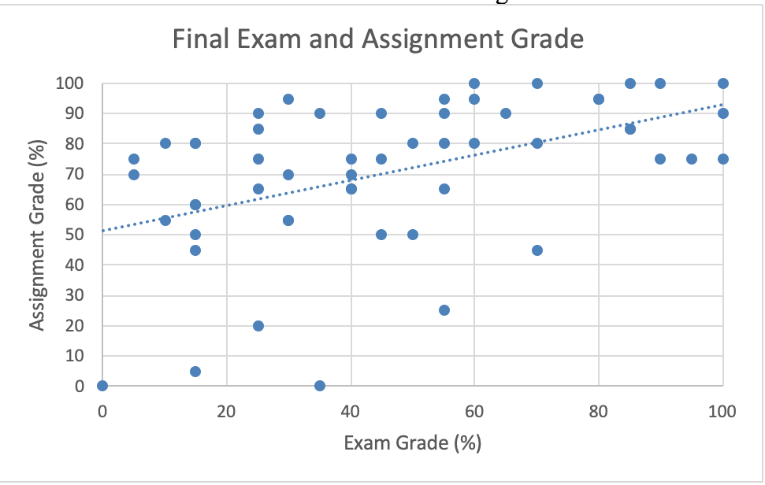
i. As seen in the graph above
b. Final exam grade and tutorials attended - 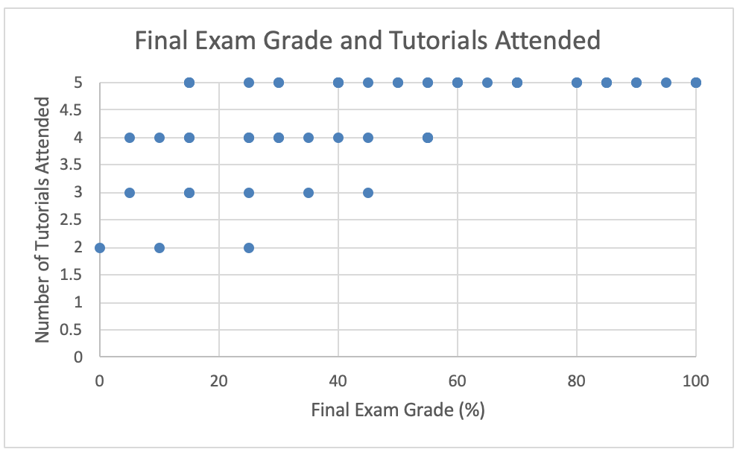
ii. As seen in the graph above, there appears to be a relationship between the number of tutorials attended by students, and their performance on the final exam. Those that attended 5 tutorials were more likely to perform well on the final exam, with 10 of those students achieving a result of 50% or more. Comparatively, those that attended 3 or less lectures, appear to have been less likely to perform well, with all of these 8 students achieving a result of 50% or less.
c. Assignment Grade and Tutorial Attendance - 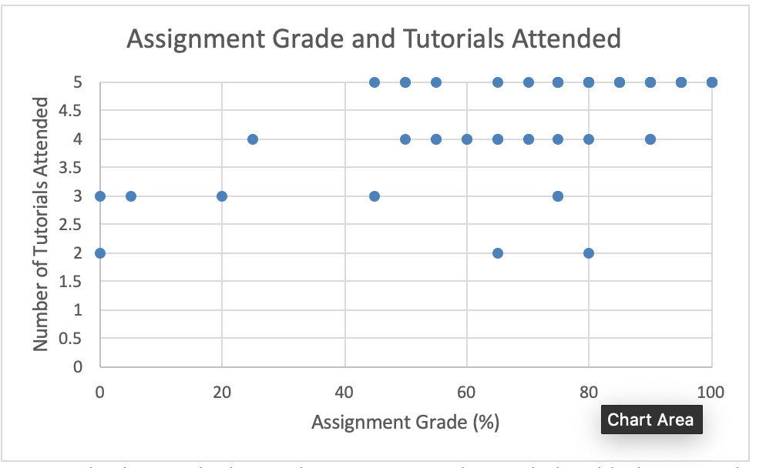

ii. As seen in the graph above, there appears to be a relationship between the number of tutorials attended by students and their performance on the assignment. Those that attended 5 tutorials were likely to perform well on the assignment, with 7 of those students achieving a result of more than 60%. As well as this, those that attended 4 tutorials were also more likely to perform well, with 6 of these students also achieving a result of 60% or higher. However, of the 7 students that attended less tutorials, such as those attending 2 or 3 tutorials, 3 of these students achieved a result over 60%, but 4 received a result of less than 50%, adhering to our interpreted relationship of a higher assignment grade resulting from a higher number of tutorials attended.

3. Calculate the sample correlation and covariance for the above 3 relationships in question 2. Carefully interpret your results. Once again use Excel for these calculations using both methods i.e. Data Analysis Tool Pack (options covariance, correlation) and using Excel formulae without use of Data Analysis Tool Pack. (Hint- if you find a discrepancy in your answers between the 2 excel methods can you explain why?)
a. The correlation between final exam and assignment grade is 0.47, indicating a moderate positive correlation. This indicates that there is a relationship between the student’s performance on their assignment, and their final exam, but their performance on the ladder is not dependent on their performance on the former.
b. The correlation between final exam grade and tutorials attended is 0.59, indicating a strong positive relationship whereby a student’s performance on the final exam is dependent on their tutorial attendance.
c. The correlation between assignment grade and tutorials attended is 0.58, indicating a strong positive relationship whereby a student’s performance on the assignment is dependent on their tutorial attendance.

4. For this question ONLY, assume that the first 26 observations are male (i.e. rows 2-27 of the original data) and the last 29 observations are female. Use Excel both with and without Data Analysis Tool Pack to test the null hypothesis that the mean of the Final_exam is equal for males and females. Interpret your results. [Topics 6-8]. Do not include analysis by gender in any further parts of the analysis i.e. questions 5, 6 and 7.
a. The average final exam grade for males, assuming the information above, is 47.31. The average final exam grade for females, assuming the information above, is 46.03. Therefore the hypothesis that the mean of the final exam is equal for males and females, is incorrect.

“Do not include analysis by gender in any further parts of the analysis i.e. questions 5, 6 and 7.”
5. Use simple regression to explore the relationship between (i) Final_exam (Y) and assignment_grade (X); (ii) Final_exam (Y) and Tutorial_attend (X). Carry out any relevant hypothesis tests using a two-tailed hypothesis test approach at the 5% significance level. You may use Data Analysis Tool Pack for this. Carefully interpret and explain. [Topics 9-10]

6. Now use multiple regression to explore the relationship between Final_exam (Y), assignment_grade (X1) and Tutorial_attend (X2). You may use Data Analysis Tool Pack for this. Carry out any relevant two-tailed hypothesis tests at the 5% significance level. Carefully interpret. If you had a magic wand and could request additional data for your analysis of this course, what extra variables would you request and why? [Topic 10-11]

7. Using your multiple regression results to predict Final_exam for a student with the mean assignment_grade and tutorial_attend equal to (i) 2 tutorials, (ii) 3, (iii) 4 and (iv) 5 tutorials. (Hint this means you will have 4 distinct predictions for Final_exam) Carefully interpret your results.

Part B: Prepare a maximum 3 slide PowerPoint presentation suitable for an audience of new students entering the Business Statistics module = 5 + 3 = 8 marks)
(i) Draw on the relevant evidence you have gathered from Part A, as well as other information/evidence not covered here but you believe is useful. Remember your audience is the new incoming student cohort. Your presentation should summarise your results from part A in a non-technical way and provide relevant conclusions/advice to the new Bus stats student cohort. Your advice and/or conclusions must be supported by evidence you provide. Maximum 3 slides.
(ii) Imagine you were shown prior student feedback on the course and one comment was “I am doing Business major X, why do I have to do a statistics course? It is not relevant”. Unfortunately, you do not know which major, X the student was referring to. Select the number of Business Majors at RMIT equal to the number of people in your group and illustrate an example of a simple or multiple regression model relevant to each of the selected majors. Explain and interpret the relevance of the regression model to the discipline major.

